## *Group member details: names and SIDs*

Our group will consist of three members. Bradley Thurlow (44779496), James Ridley (44805632) and Bryce Altman (44914792).

## *Project title*

BookBarter

## *Introduction: description of the project.*

BookBarter in its simplest form allows authors, publishers and bookstores to distribute its ebooks to various consumers on the network. BookBarter essentially allows for businesses to connect to it, sign up and start distributing a book to anyone who is using the service. BookBarter will also aid in facilitating the back end purchase of the e-books on its platform. This means that any purchase made via the site will all be handled via BookBarter so the vendor can focus on what they do best,  writing and selling books.

## *System overview: high-level description of the system including design philosophy, considerations and constraints*

BookBarter will have many aspects which connect it all together. Since it is a retail SaaS we will need to connect businesses onto the platform whilst managing the connections via the cloud on services such as AWS. BookBarter in its fullest capacity will need to serve the B2B application of serving the operational needs of its clients by distributing the e-book variant over its network, facilitating both distribution of content and the payment for the vendor.

The preliminary design for this systems will consist of many  smaller components which will need to work in order to build this one desired product. These components will all need to be connected and working in order for the system to be used in its full functionality. The system will be broken into different aspects in order to meet the various needs of the subsystems. The subsystems goals can be achieved by placing it in its respective category of front end and back end development.  The design philosophy is one which should encompass a multitude of attributes, focusing on areas of friendliness, simplicity and the end users needs. We want to make this platform so intuitive that it feels like our customers have been using it for years and couldn't picture their lives without it in the future.

Firstly we will need to implement the front end, including aspects of UI allowing for not only functionality but we must also take into consideration UX into the design. If the service isn't user intuitive or simple to use, it will ultimately lead to a terrible user experience thus hurting the business as no one will want to use the service. The front end will be a web app style page in which the user will interact with elements and features on the page without having to know anything that is happening in the back end.  This is paramount to the success of the page as it will allow for simply in its design and hopefully for a product that just works naturally.

The backend is the second major component to the system. This aspect will handle all the backend infrastructure, essentially making up the bulk of the system. The backend will need to be handled with utmost importance as it will be crucial to the success of the business. The backend will be responsible for key aspects such as file storage, sensitive material such as user details, payment details and many more important parts of the business. Since these aspects not only contain pinnacle business operations they also contain highly classified information on our customers thus meaning security must be of utmost importance.

## *System architecture: description of the system including subsystems/components of the system and their design and functionalities; preferably, with a figure showing these components and their relationships (this figure may be in System overview).*

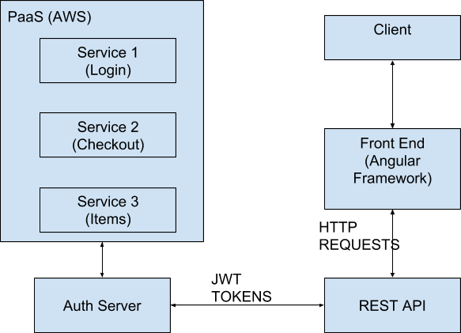

## *Implementation plan: brief description of technologies/techniques to be used with respect to each of system components described in System architecture and the timeline of implementation.*

The various components will be implemented with a powerful stack of both front end and back end languages and frameworks. We will couple this with robust security which provides highest levels of authentication to our clients.

The front end will implement a combination of HTML, CSS and JavaScript via the Angular 2 framework. This stack will be the building blocks for the front end making them aesthetically pleasing, interactive and paramount in order to effectively communicate to the backend via the client. The Angular Framework will help deliver dynamic, rich and fast content which will mimic that of a desktop application. The angular framework will also be extremely powerful in helping us with HTTP REST requests, rapid development, event handling, validation, routing and testing.

The backend will implement Python, mySQL and the Flask framework. Flask is a framework which offers tremendous benefits to microservices applications.  Flask will allow us to integrate the RESTful request dispatching, support secure cookies and acts as a simple way to integrate a web server gateway interface. The backend will also be paramount in managing all the information in the database. The database will hold all the important information relating to our users, including numerous bits of sensitive material. The database will also hold all the distributable e-books on our platform. This means that the database must be rock solid, as it is paramount to the underlying success of the business.

Timing of the implementation of these various aspects will be critical in order to get everything working succinctly. Since so many of different aspects of the project require dependencies and other applications to work, it is important that various tasks are tackled in an appropriate manner. These tasks need to be completed by various checkpoints within the semester to allow for adequate time to test out the various components. The first aspects which needs to be sorted needs to be the database. The database “”

## *References including Bitbucket project repository/wiki*

Our repository for the assignment will contain all source code and documentation for BookBarter. Our repository can be found at: <https://github.com/bradt6/BookBarter>

## 

## 